**Practical : 08**

**Aim :** Using HBase Tool

**HBase is a distributed, column-oriented database built on top of the Hadoop Distributed File System (HDFS). It is a NoSQL database that provides high scalability, fault-tolerance, and real-time data access. HBase is used to store and manage large-scale, semi-structured data.**

**HBase provides a command-line tool called the HBase shell, which is used to interact with the HBase database. The HBase shell provides a simple and interactive way to create, read, update, and delete data in HBase.**

**Some of the commonly used HBase shell commands are:**

**create:** Used to create a new table in HBase.

Syntax: create 'table_name', 'column_family'

**put:** Used to insert data into an existing table in HBase.

Syntax: put 'table_name', 'row_key', 'column_family:column_qualifier', 'value'

**get:** Used to retrieve data from an existing table in HBase.

Syntax: get 'table_name', 'row_key'

**scan:** Used to retrieve all data from an existing table in HBase.

Syntax: scan 'table_name'

**delete:** Used to delete data from an existing table in HBase.

Syntax: delete 'table_name', 'row_key', 'column_family:column_qualifier'

**disable:** Used to disable a table in HBase.

Syntax: disable 'table_name'

**drop:** Used to delete a table in HBase.

Syntax: drop 'table_name'

**Apart from the HBase shell, HBase also provides a web-based user interface called HBase Web UI, which can be used to monitor and manage HBase clusters. The HBase Web UI provides a graphical interface to view HBase tables, regions, and other system statistics.**

**Overall, HBase is a powerful NoSQL database that provides high scalability, fault-tolerance, and real-time data access. The HBase shell and HBase Web UI make it easy to interact with HBase and manage HBase clusters.**

**Follow Below Steps:**

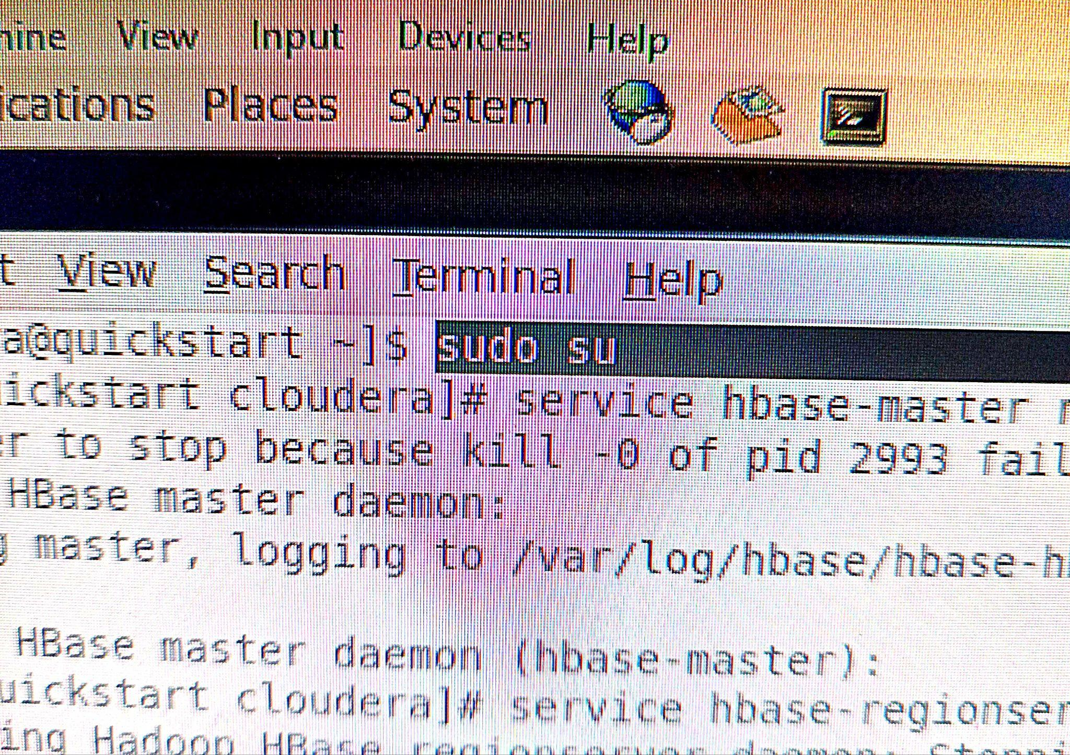

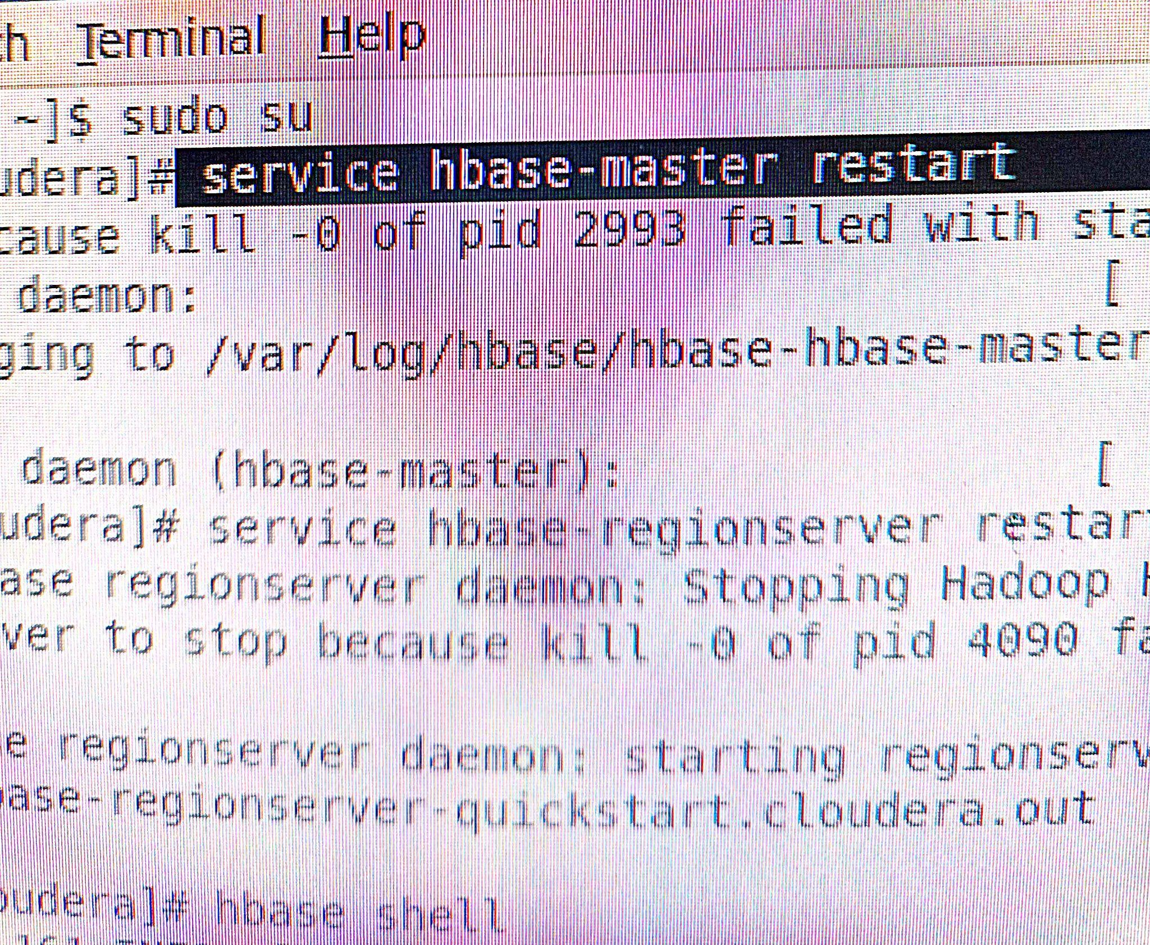

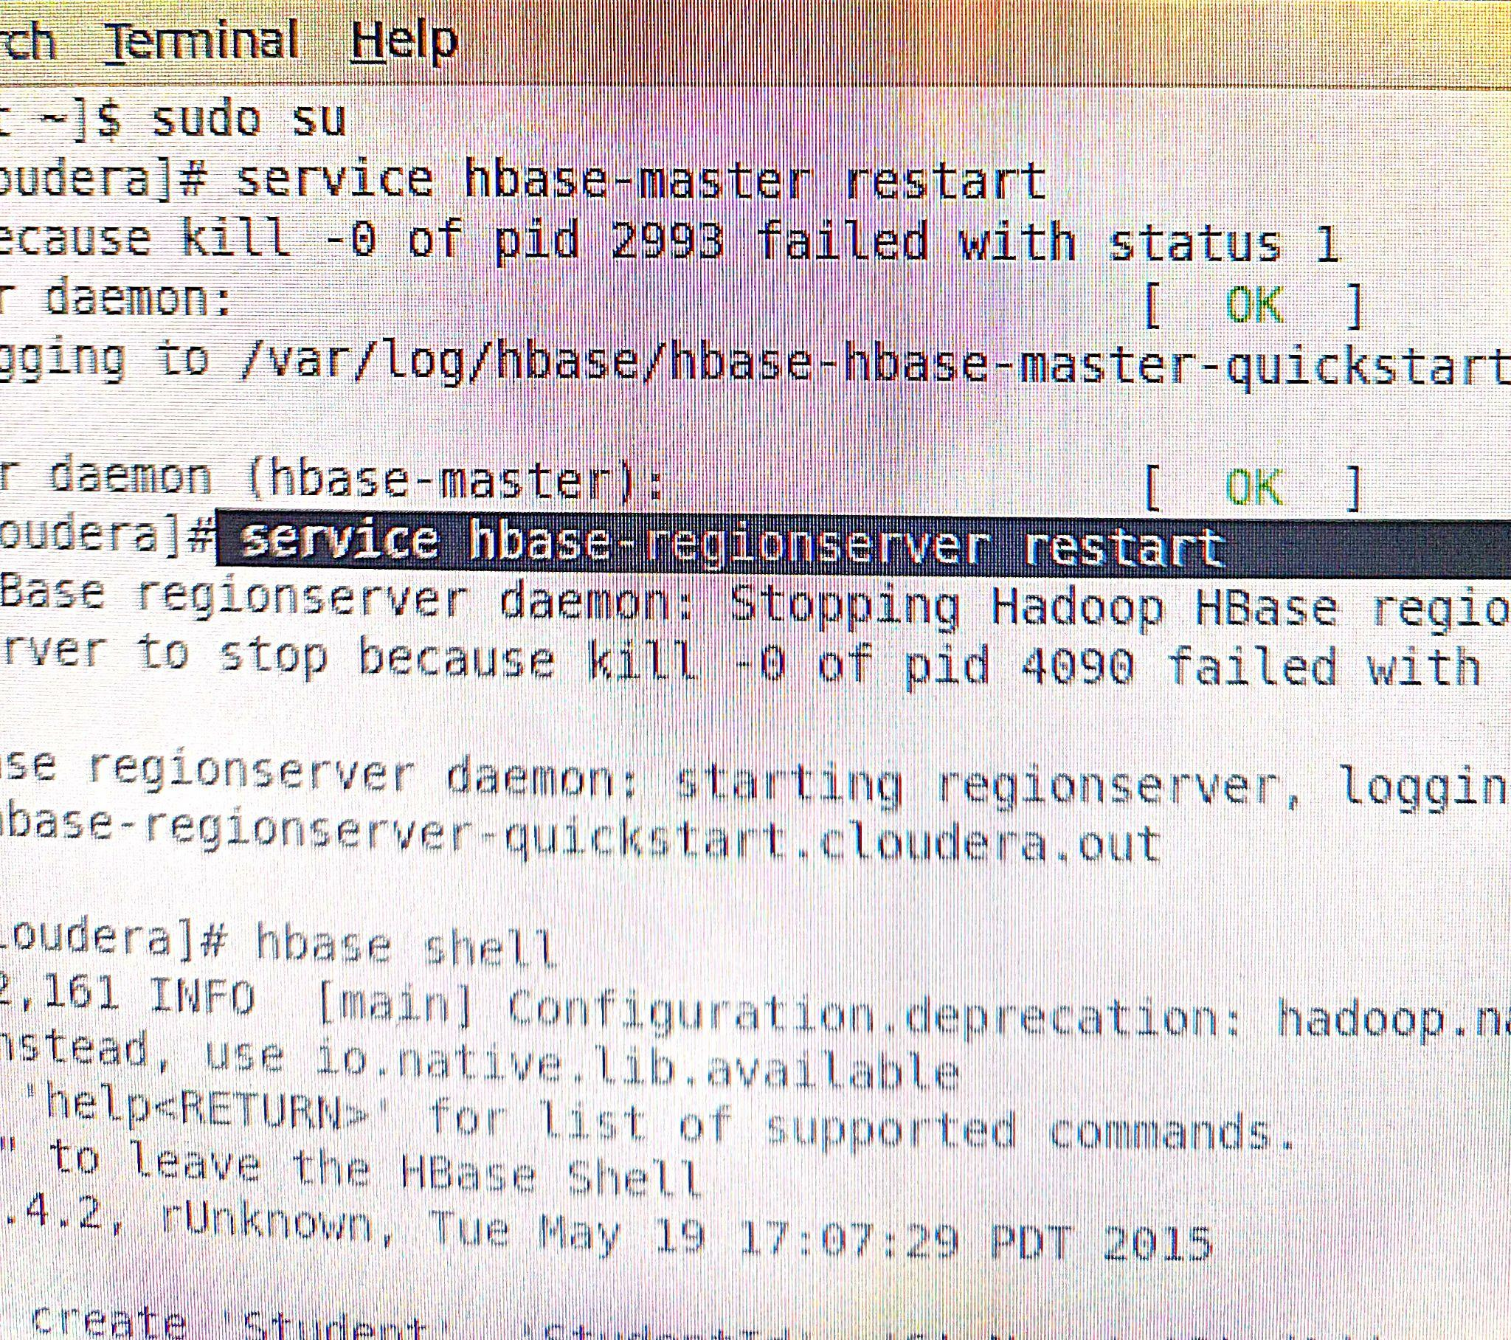

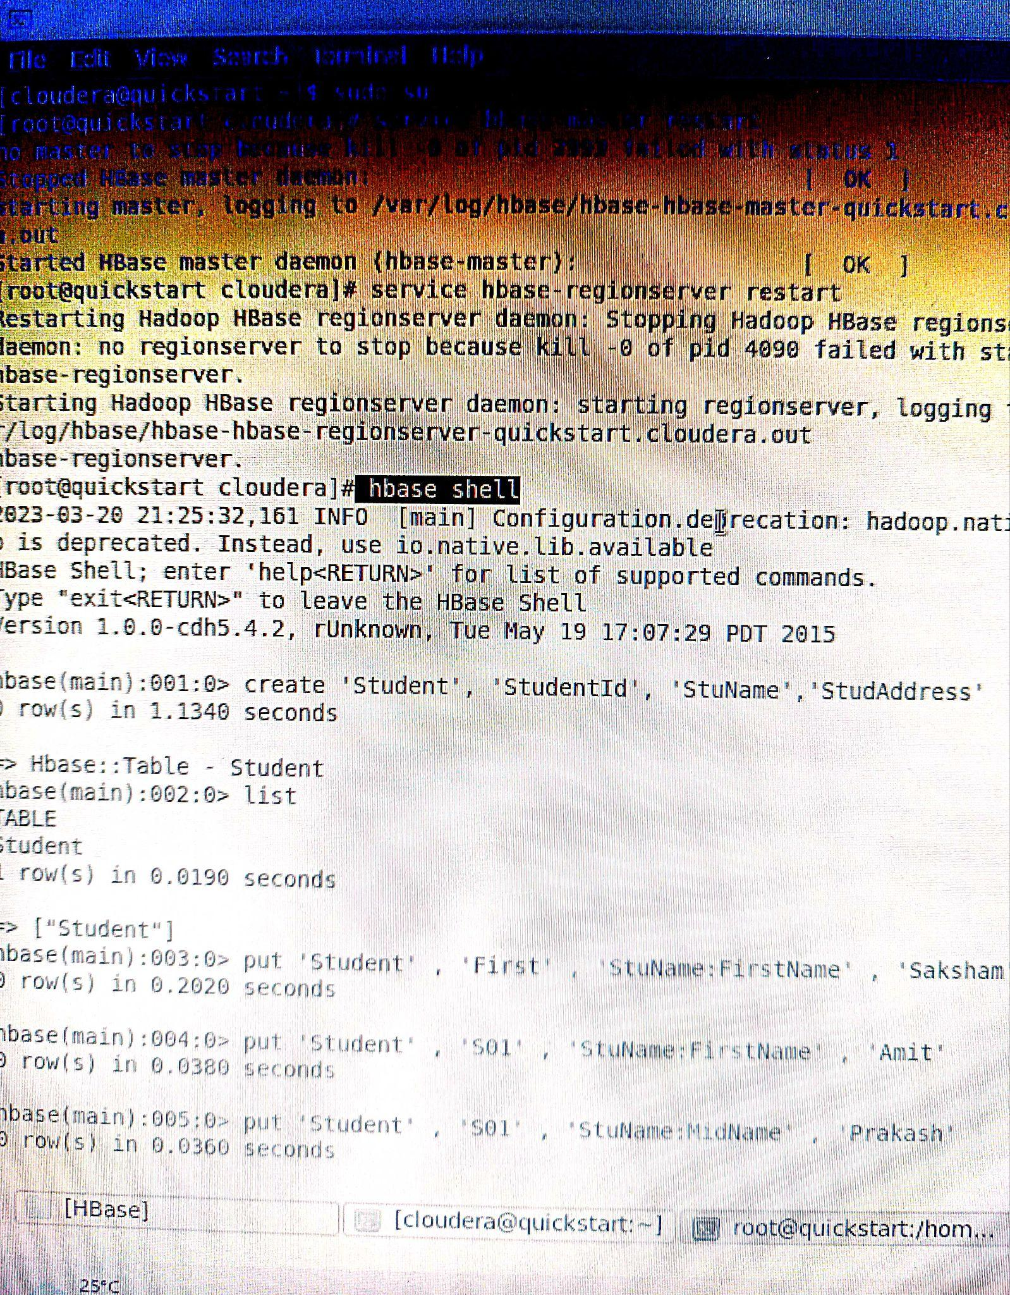

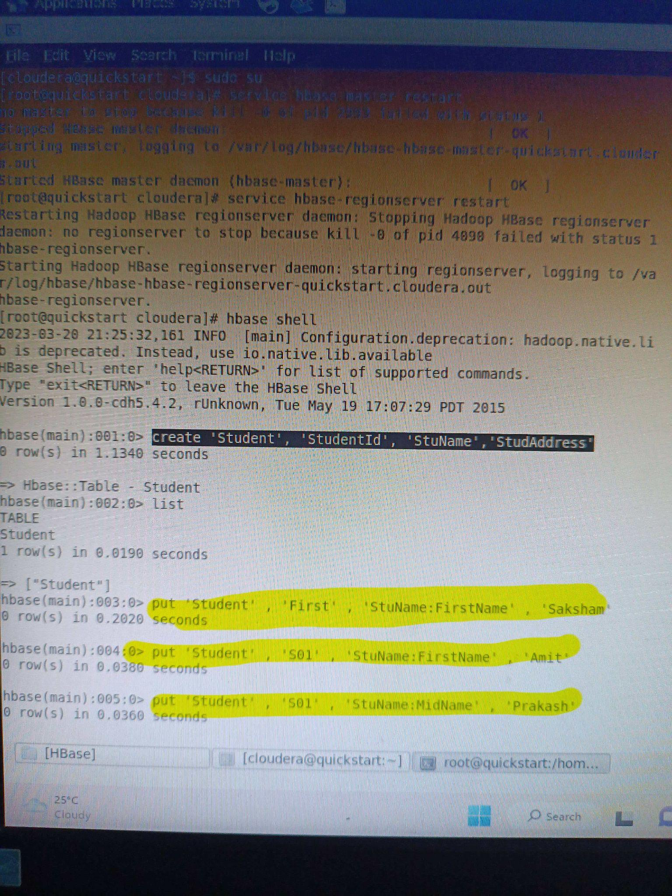

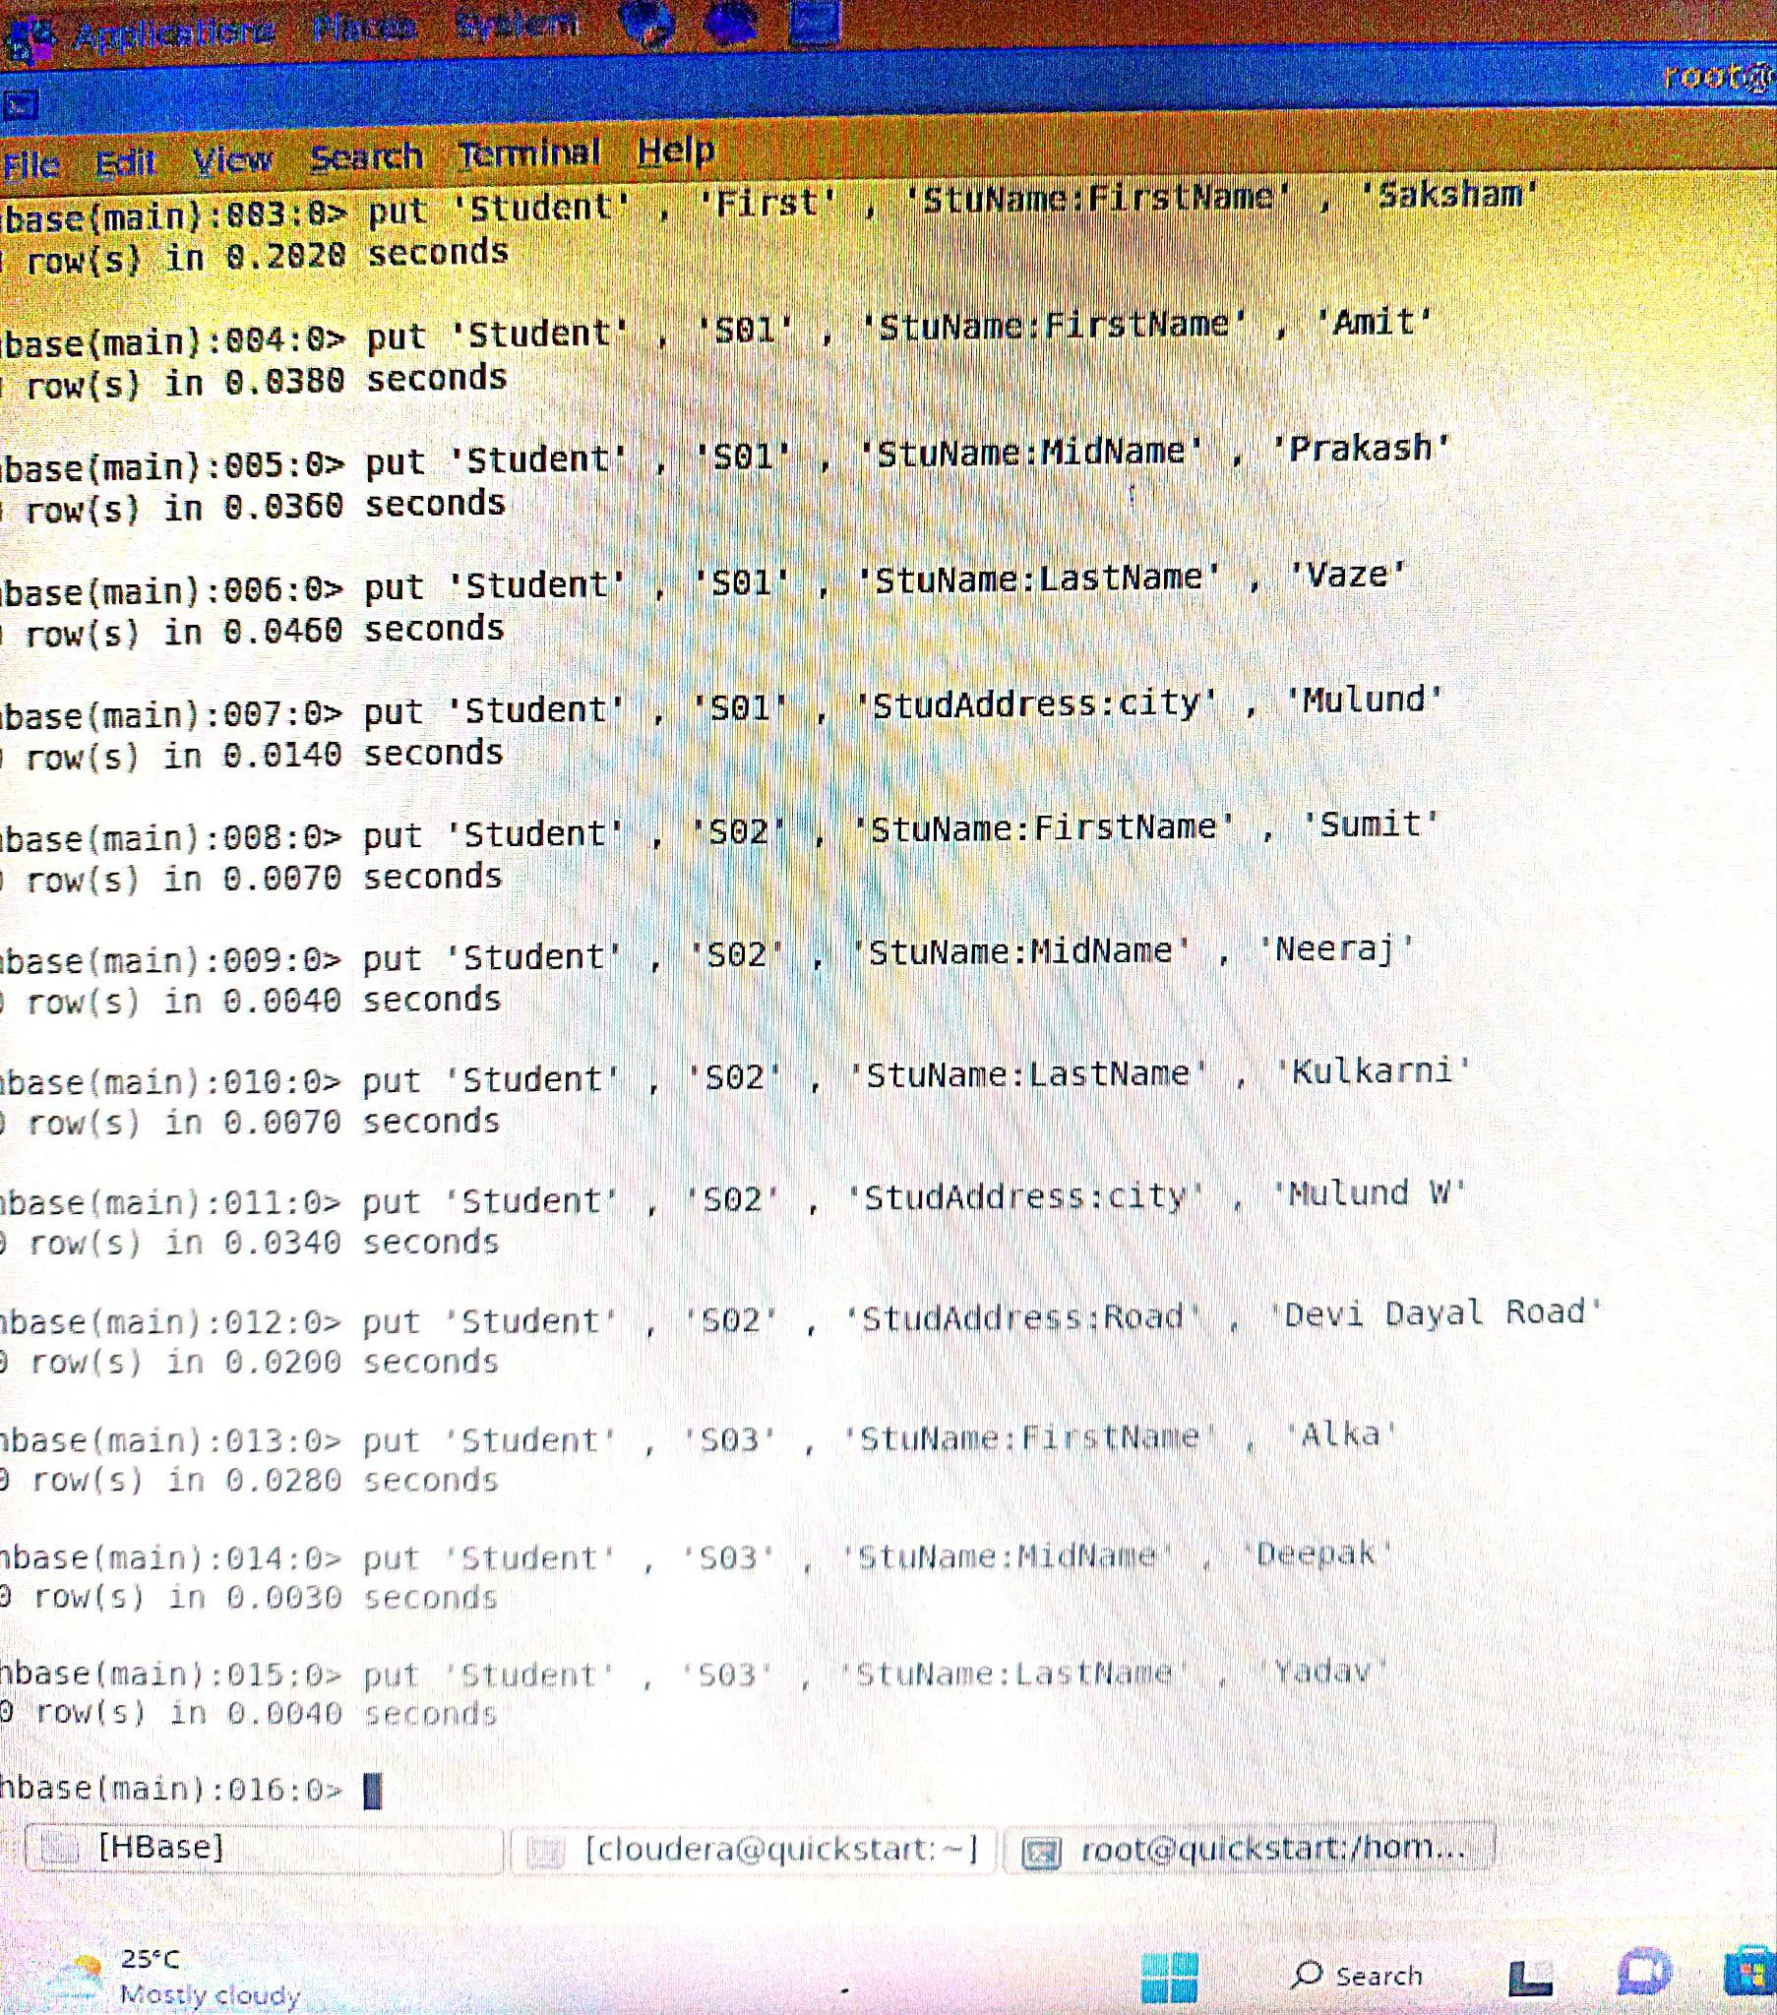

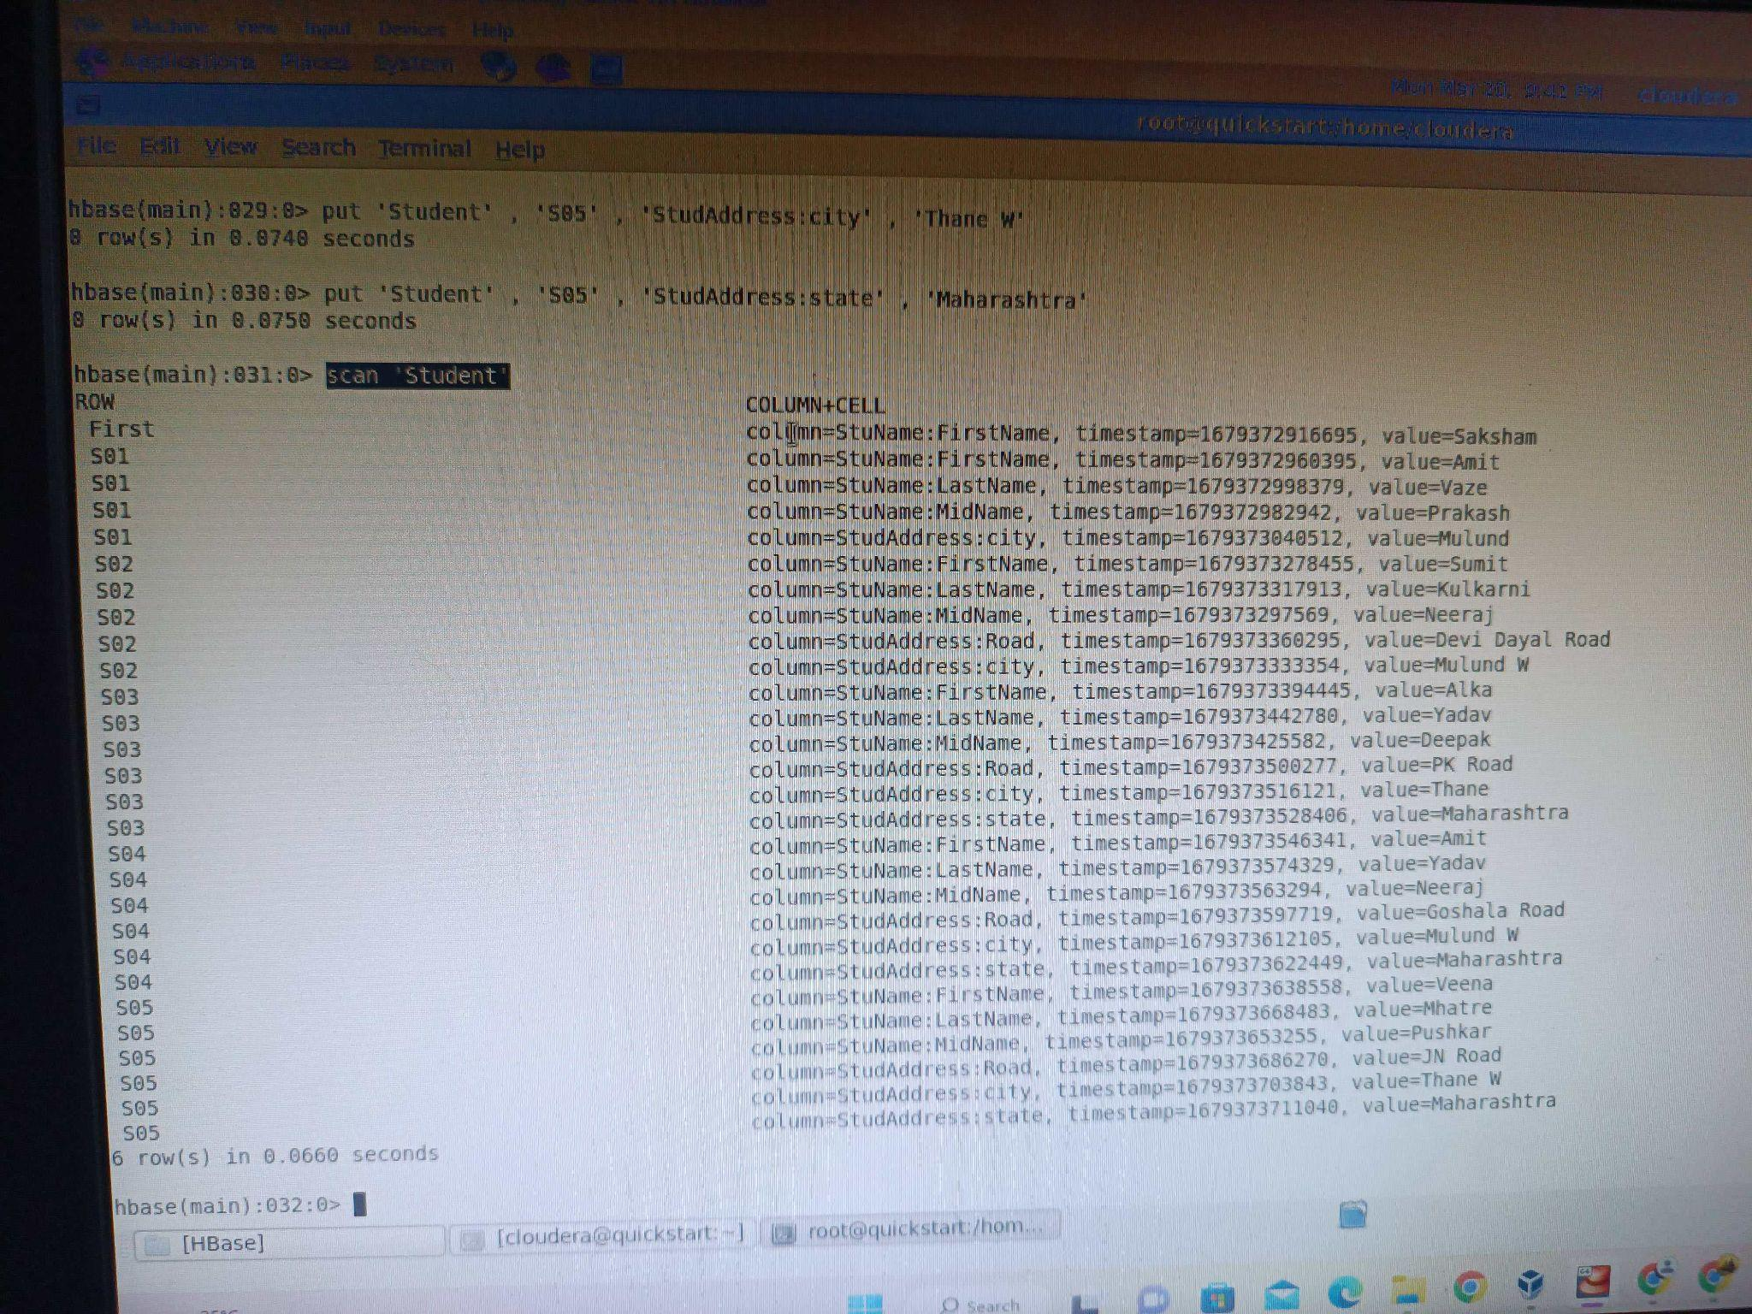

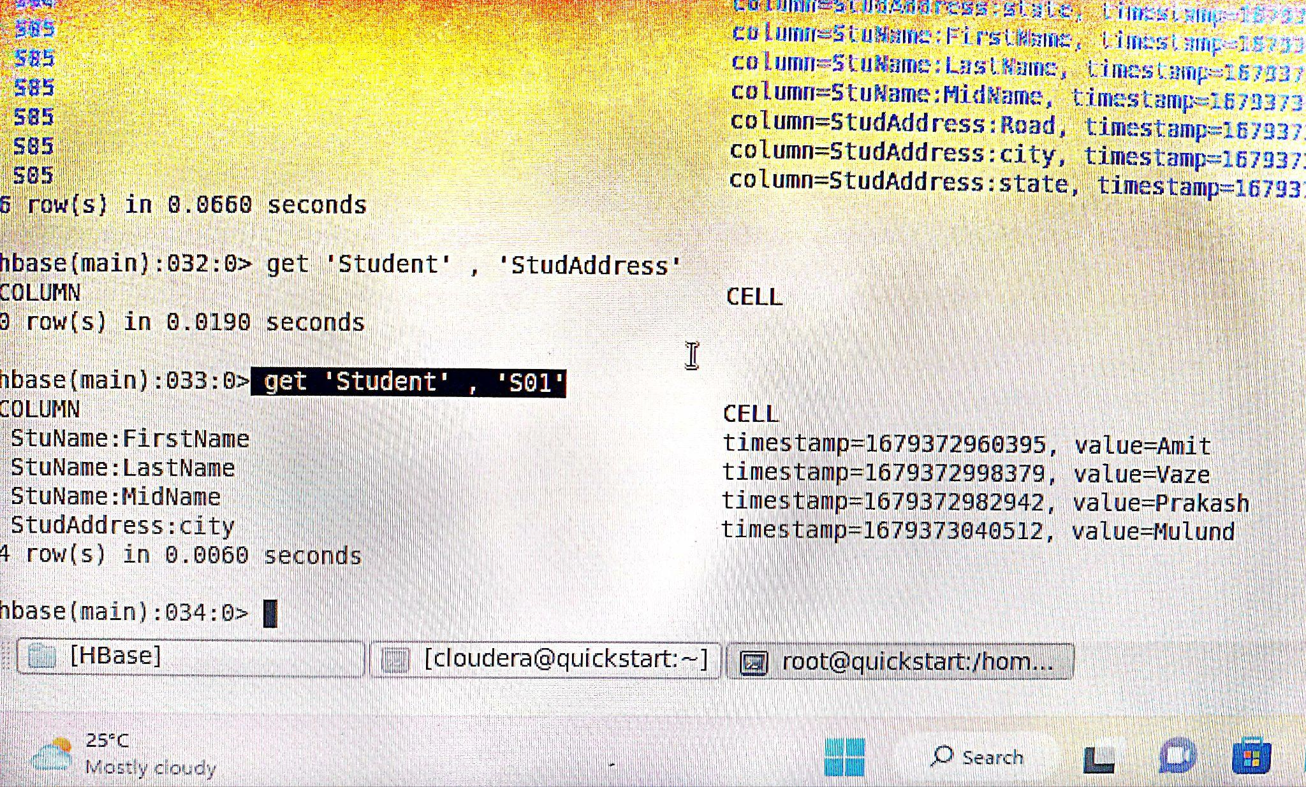

**Done**